FLOW
For Living Oceans and Water

FLOW
For Living Oceans and Water

FLOW
For Living Oceans and Water

Context

Did you know that a human being can ingest up to 5g of plastic per week, which is equivalent to a credit card? This figure comes from a WWF study on the ingestion of plastic in air, water and food.

There are a multitude of chemical combinations that can be used to create plastic, giving it an infinite number of possible shapes. As a result, it is particularly complex to collect and recycle. According to TaraOcean, France's first publicly recognised foundation dedicated to the ocean, "In France, for example, 73.6% of plastics are landfilled or incinerated, emitting pollutants that are still poorly understood into the air, water and soil. Even the most recyclable plastics, such as polyethylene (PET), are recycled only to a very limited extent: currently, barely more than half of PET water bottles are recycled. The flow of plastic to the ocean is not just uncollected waste. Because of the weather, plastics break down and release microplastic particles. These almost invisible micro entities represent a colossal flow, with each rainfall carrying these particles to rivers and the ocean.
Today, we know that all forms of plastic are harmful to both animals and plants. The most visible impact is that of macroplastics, which marine animals ingest and in which they can also become trapped (fishing nets, etc.). According to the taraocean foundation: "The vast majority arrive in the form of microplastics (measuring between five millimetres and a few hundred nanometres) or even nanoplastics, smaller than one micrometre".
These plastic particles threaten marine ecosystems and scientists continue to study their toxicity. At this microscopic scale, these plastic particles can have a dramatic effect on organisms.

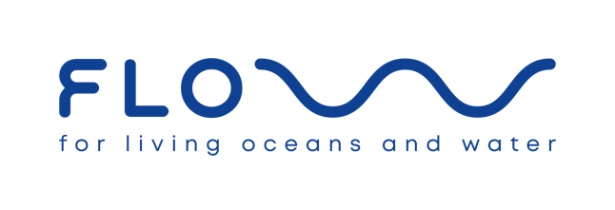
In this context, "FLOW" is a project of "initiatory journey" in search of concrete solutions, of human encounters, in the service of a collective and committed fight. This one-year expedition will take place all along the European coasts and is part of our university course between our third and fourth year of engineering.

FLOW, an acronym for "For Living Oceans and Water", is a project for living oceans and water. It is part of a sustainable approach to ecosystems and their protection. FLOW also, because in "positive psychology", "flow" is a "mental state reached by a person when he or she is completely immersed in an activity and is in a maximum state of concentration, full commitment and satisfaction in its accomplishment". Finally, "Flow" is also a musical term for the rhythm of music or spoken words.
F L O W is thus a resolutely positive and committed project for the sustainability of water and the oceans, with a rhythm and resonance commensurate with the challenge and its urgency.
Provisional date for the grand departure: 17 October 2022!

Objectives and Expected Results

Objectives

The main objective of F L O W is to contribute to the fight against micro and macroplastic pollution of water and oceans.
To achieve this, there are three specific objectives:
- To collect information on the presence of macro and microplastics on the European coastlines and riverbanks in order to contribute to research on their impact worldwide. This information will be processed by the TaraOcean laboratory.
- To meet, in each of the countries visited, actors looking for solutions in the fight against water and ocean pollution
- To give new visibility to this issue and above all to highlight existing and possible solutions via a video film in order to raise awareness and awaken the general public to this important and urgent issue.

Expected results

Scientific results
- Some forty samples taken in 19 countries of the European Union. Samples that can be used and valorised within the framework of a protocol of the TaraOcean foundation in collaboration with Jean-François Ghiglione, Scientific Director.
- An overview of European legislation and specific national regulations on plastics in the different EU countries.

Media' results
- 20 interviews with university professors specialising in this field.
- 20 interviews with organisations offering solutions to combat water pollution.
- The production of "micro-trottoirs" according to the meetings.
- 1 documentary film (52') for distribution via different channels (schools, universities, social media, partner media).

Resources

Technical means / Estimated budget

Van type vehicle (with the most environmentally friendly engine possible) | 20.000
Estimated energy requirement for the route | 6.000
Food (300 days, 2 people) | 15.000
Video equipment (GH6; microphone; drone) | 4.500
Sampling equipment | In progress with taraocean
Unforeseen | 4.500
Total | 50.000

Part of the budget will be financed by their savings. (3000€ at this point)

Human and financial resources

Pablo and Elmo
The first resources are the project leaders. Pablo Bourcelet and Elmo Swenne, bioengineering students respectively at UCL and ULB in Belgium. They are finishing their third year and have decided to set up and run FLOW before starting their master's degree.
Their paths crossed when they were youth workers and then animators in youth movements. They share the same values, passions, such as rugby and the FLOW project, as well as the same bio-engineering studies.

Their academic background gives them a scientific background that will enable them to carry out field analyses. They undertake this journey as "the first adventurers of a crew".

Soraya
Soraya joined the project in October 2022. Seduced by the project, she decided to help us by taking care of the communication and social networks aspect.

A crew to come according to the meetings
They hope that each encounter during the journey on the European continent can be a gust of wind in the sail to advance this project.

Technical or financial partnerships
Pablo and Elmo are considering financial partnerships in order to cover the estimated costs of setting up and running the project. For this, they are counting on participatory financing as well as on sponsoring. They also hope for many human partnerships in order to exchange and benefit from mentorship throughout the project.
They are also planning technical collaborations that should enable them to continuously improve their knowledge in the service of FLOW.

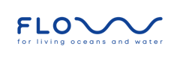
They invite you to tell your friends and family about FLOW and to follow and share FLOW on social networks:
FLOW - For Living Oceans and Water - flow_project_
https://flowproject.be
flow_project_ F L O W

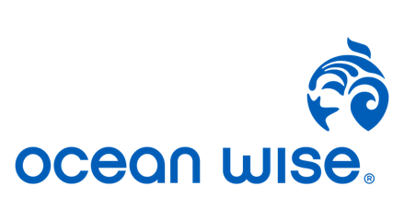
Would you like to support them? You can do so via the "gofundme" platform, via IBAN: BE13741006380939 or via their website using the "donate" icon.
Would you like to contact them? Do not hesitate to send them a message to the following email addresses : p.bourcelet@gmail.com et elmosbrc@gmail.com

Partners

Partnerships envisaged
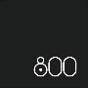
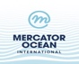
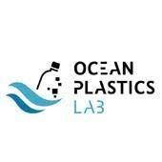
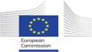
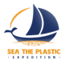
“Croyez pour être forts Aimez pour être heureux.”. de Victor Hugo dans "Océan"

Countries crossed: 19 countries of the European Union. (France, Spain, Portugal, Italy, Serbia, Slovenia, Croatia, Greece, Bulgaria, Hungary, Estonia, Latvia, Poland, Germany, Netherlands, Denmark, Sweden, Finland, Belgium). This represents approximately 20,000 km.

